The Falling and the Rising

Props

*NOTE- some of the military stuff can be discovered in the materials onstage for set dressing.
All military equipment should be current, desert style camo

Scene 1 Barracks
Laptop maybe with an external camera
Small photo of 13 year old daughter
Military tactical backpack
Rifle

Scene 2 MASH unit
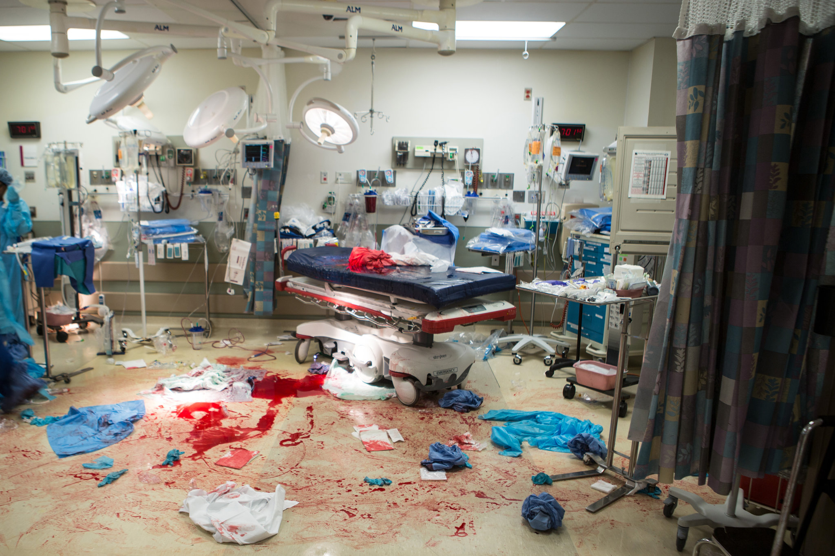
All necessary medical equipment-rolling
2 IV stands with bags
Tubing
3 clipboards
Wound dressing, blood stained
Needles
Something to indicate a laryngoscope
Monitors
Etc.

Scene 3-Toledo
Military issue chair- standable

Scene 4- Jumper
Laptop
Rolling stand for computer, or easily removeable desk and chair
Hospital chart and folder
Military parachute
Blue silk parachute
Military Parachute pack- should match the one on the Jumper costume
Flask

Scene 5 -Colonel

Dining table set for two, candles, wine
Two chairs
Family photos- husband, wife, two kids, two grandkids
2 TV dinners
Military pistol

Scene 6 Homecoming
Large cross to be hung from scaffold
Wheekchair- tricked to hide legs from knee down?
Hand sized Bible

